“The fear of the LORD is the beginning of wisdom;
a good understanding have all those who do
His commandments.” -- Psalm 111:10
- Please show all your work! No partial credit will be given for incorrect answers with no work shown. Please draw a box around your final answer.
- Calculators are permitted, but no notes, text, laptops, PDAs, or electronic dictionaries. Cell phones should be muted and left in your pocket or bag.
- Table 3 is attached to the back. You may detach it for your reference.
Total marks: 70

- A pharmaceutical company has devised a test for Alzheimer’s disease. Assume that if a person does not have Alzheimer’s, the test has a 5% chance of giving a false positive (95% specificity). Assume that if a person has Alzheimer’s, the test has a 72% chance of detecting it (72% sensitivity). (continued next page)
  - Suppose 400 people use the test, and that 80 of those people really have Alzheimer’s. Draw an event tree for the outcomes of the test, and label the tree with probabilities for each branch of the tree. [5]
Alzheimer’s: 20%
No Alzheimer’s: 80%
Test +: 72%
Test -: 28%
Test +: 5%
Test -: 95%
  - How many people in this group will test positive for Alzheimer’s? [3]
(.20)(.72) + (.80)(.05) = 18.4%
(.184)(400) = 73.6 people
  - Of those, what fraction really have Alzheimer’s? [2]
(.20)(.72) / (.184) ≈ 78.26%
- Mark each of the following variables as categorical (G), ordinal (O), discrete (D), or continuous (C). [5]
  - Daily vitamin C intake in mg Continuous
  - Number of children born albino in a year: Discrete
  - Gender (i.e., male or female): Categorical
  - Service questionnaire: Very Good, Good, Fair, Poor: Ordinal
  - Religion (e.g., Protestant, Catholic, Jewish, Muslim, etc.) Categorical
- Mark each of the following statements as descriptive (D) or inferential (I). [4]
  - Our company’s drug is effective in 93.8% of patients. Inferential
  - Our company’s drug was effective on 60% of the 3000 patients
we studied. Descriptive
  - The chance of getting struck by lightning is 1 in 120,000. Inferential
  - With 95% confidence, the mean height of 2-year-old
American boys is 87cm ±3cm. Inferential
- The blood glucose level (in mg/dLi – milligrams per deci-liter) of a patient is measured over the course of several weeks. The mean blood glucose level is 85 mg/dLi, and the standard deviation is measured to be 75 mg/dLi. Is it reasonable to assume that the blood glucose level is normally distributed? Why or why not? [3]
No. If the distribution were normal, then 12.92%
of the measurements would be negative, which is impossible.
We calculate this from z = (0-85)/75 ≈ -1.13,
in Table3: 0.1292
- The length (height) of a population of 1-year-old boys is normally distributed with mean 73cm and standard deviation 4cm.
  - A particular 1-year-old boy is 65cm long. What percentile does his length rank on the growth chart? [2]
z = (65-73)/4 = -2.00
Table3: 0.0228: 2.28th percentile
  - What is the 3rd quartile height? [3]
0.7500: Table3: z ≈ 0.675
y = 73 + 0.675(4) ≈ 75.7cm
  - What is the probability that the length of a 1-year-old boy in this population is within 0.5cm of the mean? [3]
z = ±.5/4 = ±0.125
Table3: 0.5478 – 0.4522 ≈ between 9.56% and 10.34%
  - If we did not know the mean length, how many 1-year-old boys would we need to measure to estimate the mean length of the population to within ±0.5cm, with 95% confidence? [4]
95% conf => z = 1.96
1.96 = 0.5/(SE) = 0.5/(4/√n)
n = (1.96(4)/0.5)² ≈ 245.86 => 246 boys
- Give an example of a pair of events that are independent. Be sure to define each event clearly. Also define the total sample space. [3]
There are many possible answers; a simple one is flipping a coin multiple times: the event “heads on first flip” is independent of the event “heads on second flip”. The whole sample space is { (H,H), (H,T), (T,H), (T,T) }.
- Assume the list below represents the raw data for an experiment measuring serum albumin level. Draw a relative frequency histogram, classifying the data by tenths of g/dL. [4]
3.50 g/dL | 3.55 g/dL | 3.71 g/dL
3.76 g/dL | 3.79 g/dL | 3.84 g/dL
3.86 g/dL | 3.91 g/dL
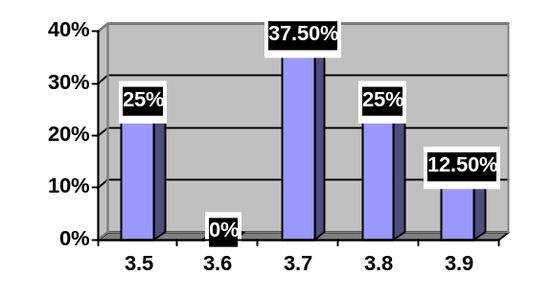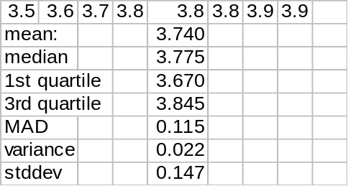
  - Calculate the mean serum albumin level for the sample. Please show your work. [2]
3.74
  - Calculate the standard deviation of the serum albumin level in the sample. Please show your work. [6]
0.147
  - Draw a boxplot for the data. Show all your work. [5]
min = 3.50
1st = 3.63
med = 3.775
3rd = 3.85
max = 3.91
- Let A represent marathon runners. Let B represent people with heart disease. Translate each of the following statements into probability notation using A and B, and draw a Venn diagram in the box provided, shading in the region described. (If it’s a conditional probability, write “not applicable” in the Venn diagram.)
  - One quarter of the people in this study are runners. [3]
P(A) = 0.25
A
  - The chance of heart disease in this study is 8%. [3]
P(B) = 0.08
B
  - One out of 10 of the runners in this study have heart disease. [3]
P(B|A) = 0.10 (Venn diagram not applicable)
B
  - What is the probability that someone in this study is a runner with heart disease? [2]
P(A and B) = P(A)P(B|A) = (0.25)(0.10) = 2.5%
  - What fraction of the people in this study neither run nor have heart disease? [2]
P( (A and B)^{C} ) = 1 – P(A) – P(B) + P(A and B)
= 100% - 25% - 8% + 2.5%
= 69.5%
  - In this study, is running independent of heart disease? Why? [3]
No: P(B|A) = 10% is not the same as P(B) = 8%.
Runners have a higher chance of heart disease (in this study).

